Level 0.5: The Actual STM32F103C8T6 Memory Map

BASICS
Now we move from generic MCU theory → actual STM32 hardware.
This is where things start becoming very useful.
Before I give you the STM32 memory map, I want you to reason about one thing.
Think about this scenario
Suppose STM32F103C8T6 has:
Flash
SRAM
GPIO
Timers
UART
ADC
The CPU needs some way to access all of them.
We already learned that peripherals can be memory-mapped.
So imagine the STM32 address space looks something like:
0x00000000
│
├── ?
│
0x20000000
│
├── ?
│
0x40000000
│
├── ?
│
0x80000000
│
└── ?
Your checkpoint 🧠
Without searching:
Q1. Where do you think SRAM should be located?
A. Around 0x00000000
B. Around 0x20000000
C. Around 0x40000000
Q2. Where do you think peripheral registers such as GPIO registers should be located?
A. Around 0x00000000
B. Around 0x20000000
C. Around 0x40000000
Q3. If a GPIO peripheral has:
GPIO base address = 0x40010800
Register offset = 0x04
what would be the register address?
Don't worry about whether those are the exact GPIO addresses yet. This is purely testing whether you've understood:
Register address = Base address + Offset
Answers:
1. B
2. C
3. 0x40010804

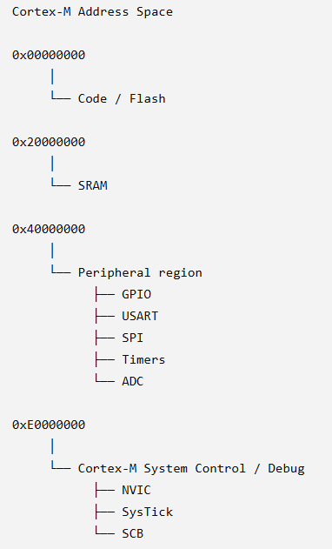

Next challenge: let's connect this to an actual STM32 register
Suppose we have:
GPIO base address = 0x40010800
and a register:
Offset = 0x04
We already calculated:
Register address = 0x40010804
Now imagine:
#define GPIO_REG (*(volatile uint32_t *)0x40010804)
and the hardware currently contains:
0x40010804 → 0x00000000
If we execute:
GPIO_REG |= (1 << 5);
Don't calculate immediately. Tell me the physical chain:
CPU → ? → ? → ? → GPIO pin
Fill in the missing stages. This is the bridge from C code to actual electricity on a pin.
My chain: CPU -> Compiler -> Machine Language -> ? -> GPIO pin
A better chain is:
C source code
↓
Compiler
↓
Machine instructions
↓
CPU executes instruction
↓
Bus
↓
GPIO peripheral/register
↓
GPIO hardware
↓
GPIO pin

For our example:
GPIO_REG |= (1 << 5);
the conceptual journey is:
C code
↓
Compiler
↓
Machine instructions
↓
CPU executes them
↓
CPU performs read/modify/write through the bus
↓
GPIO register
↓
GPIO hardware changes its output state
↓
Pin 05 changes electrical state

Mini-checkpoint 🧠
Suppose:
GPIO register = 0x00000000
and we execute:
GPIO_REG |= (1 << 5);
Answer these without looking anything up:
- What is (1 << 5) in hexadecimal?
- What will the register contain afterward?
- Does the CPU change the address 0x40010804, or the value stored at that address?
- Which bit changed?

1. (1 << 5) → ✅
You wrote:
00100000
Correct.
As hexadecimal:
0010 0000 = 0x20
So:
(1 << 5) = 0x20

2. Final register value → ❌
Initially:
0x00000000
Then:
GPIO_REG |= (1 << 5);
which means:
0x00000000
OR
0x00000020
-----------
0x00000020
So the final value is:
0x00000020
You wrote 0x00100000, which corresponds to a much higher bit.
A useful habit: bit 5 = 2^5 = 32 = 0x20.

3. Address vs value → ✅
Exactly.
The address remains:
0x40010804
The value stored there changes:
Before:
0x40010804 → 0x00000000

After:
0x40010804 → 0x00000020
This distinction is fundamental. 🔑

4. Which bit changed? → ✅
Correct.
Bit numbering starts from 0:
Bit: 7 6 5 4 3 2 1 0
│ │ │ │ │ │ │ │
0 0 1 0 0 0 0 0
↑
bit 5
So bit 5 is the 6th bit from the right.
One rule to burn into memory:
bit 0 → 0x01
bit 1 → 0x02
bit 2 → 0x04
bit 3 → 0x08
bit 4 → 0x10
bit 5 → 0x20
bit 6 → 0x40
bit 7 → 0x80

Now we're ready for the real STM32F103 memory map and peripheral address calculation, where we'll stop using imaginary addresses and start using the actual MCU architecture.

